

Assessment Cover Page

Student Full Name: | Andrea Diaz Medrano
Student Number: | 2026627
Module Title: | Strategic Thinking
Assessment Title: | CA 1 – Capstone Project Proposal
Lecturer/Supervisor: | Taufique Ahmed
Assessment Due Date: | 21-09-2026
Date of Submission: | 25-10-2026
Contents
I. Project Title 2
II. Introduction 3
III. Problem Definition 4
IV. Aim and Objectives 4
V. Scope 4
VI. Methodology 4
VII. Data Sources 4
VIII. Expected Deliverables 4
IX. Project Timeline 5
X. Ethical and Legal Considerations 5
XI. References 5

I. Project Title
Predictive Analytics for corporate greenhouse gas emissions (tCO₂e): Supporting Strategic Sustainability Decision-Making.

II. Introduction
The Earth's atmosphere is composed of various gases, with nitrogen and oxygen being the most abundant, at concentrations of 78% and 21%, respectively. The remaining 1% includes some gases known as trace gases, such as ozone, sulfur dioxide, nitrogen oxides, and carbon dioxide (CO₂).
The CO₂ is a gas that forms part of the atmosphere’s natural composition, and its presence is a vital part of Earth’s carbon cycle (EPA, 2026) that is, this cycle describes the natural circulation of carbon between the atmosphere, the oceans, the land, plants, and animals, as shown in Figure 1 below.
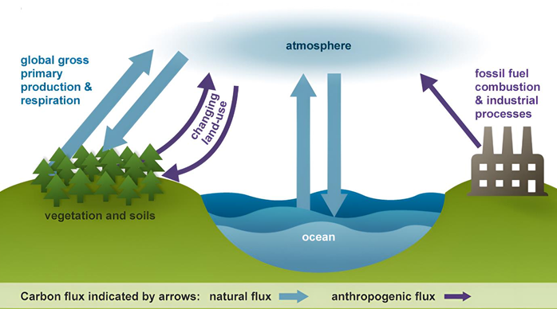
Figure 1. Carbon cycle (Habeeb Fadya A., 2024).
The cycle is usually thought of as four main reservoirs of carbon interconnected by pathways of exchange. The reservoirs are the atmosphere, terrestrial biosphere (usually includes freshwater systems), oceans, and sediments (includes fossil fuels) (Environmental Protection Agency (EPA), 2013).
The annual movements of carbon, the carbon exchanges between reservoirs, occur because of various chemical, physical, geological, and biological processes (Environmental Protection Agency (EPA), 2012). For example, through photosynthesis, plants absorb carbon dioxide from the air and use this carbon to form their leaves, stems, and roots. This means that plants store carbon. When animals feed on plants, they use this carbon as a source of energy and to build their own bodies. The ocean also absorbs carbon dioxide and is considered the reservoir with the greatest capacity for carbon absorption near the Earth's surface, but most of that reservoir does not participate in rapid exchange with the atmosphere (Environmental Protection Agency (EPA), 2013).
In swamps and on the ocean floor, dead plants and animals do not decompose completely and end up buried in layers of sediment. Over millions of years, heat and pressure transform the carbon from these plants and animals into fossil fuels such as coal, oil, and natural gas (Environmental Protection Agency (EPA), 2012).
However, human activities, particularly those related to the combustion of fossil fuels and certain industrial processes, have disrupted this balance by increasing the concentration of greenhouse gases, such as CO₂, water vapor (H₂O), methane (CH₄), nitrous oxide (N₂O), ozone (O₃), and fluorinated gases such as CFCs.
Greenhouse gases reduce the amount of infrared radiation that escapes directly into space by absorbing and re-emitting part of this energy within the atmosphere. The resulting increase in heat retained within the climate system contributes to global warming.
Currently, corporations have a vital role to play in efforts to mitigate global warming as the dominant producers of industrial greenhouse gas (GHG) emissions (John Downie, 2011). These emissions can be quantified using greenhouse gas inventories, which may include Scope 1, Scope 2 and Scope 3 emissions (described below in Figure 2) and expressed in metric tons of CO₂ equivalent (tCO₂e).
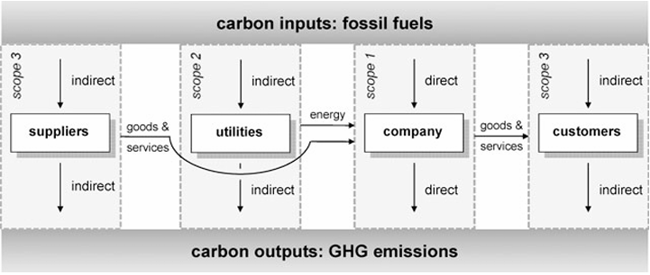
Figura 2. GHG emissiones (Timo, 2008).
The measurement and assessment of greenhouse gas (GHG) emissions have become increasingly important today due to the evolution of environmental regulatory frameworks that require organizations to quantify, report, control and mitigate the impact associated with their emissions, considerably because of EU Commission announced its intention to reduce net greenhouse gas (GHG) emissions by at least 55% by 2030 compared to 1990 (Rainer Kasperzak, 2023). These frameworks include, for example, the Greenhouse Gas Protocol (GHG Protocol), the European Union’s Corporate Sustainability Reporting Directive (CSRD), and the climate disclosure standards developed by the International Sustainability Standards Board (ISSB). These initiatives reflect a growing trend toward greater transparency and corporate accountability regarding climate change.
Additionally, GHG emissions serve as key environmental indicators within the context of ESG (Environmental, Social, and Governance) criteria, as they enable organizations to assess their environmental performance, identify risks and opportunities related to climate change (Rainer Kasperzak, 2023), and support decision-making aimed at reducing and mitigating their environmental impact.
However, having historical data on emissions does not necessarily enable organizations to anticipate future trends or assess how different operational decisions might alter their trajectory. This presents an opportunity to apply data analysis and forecasting techniques.
However, while historical greenhouse gas emissions are an important indicator of an organization’s environmental performance, historical reports alone do not necessarily provide sufficient information to support forward-looking decision-making. Organizations must also understand how their emissions may evolve under different business and operational conditions.
Historical business and environmental data can be used to identify patterns and relationships between corporate characteristics and greenhouse gas emissions. This presents an opportunity for data analysis and the development of predictive models to estimate future emissions; in turn, scenario analysis can be used to explore how changes in relevant variables might affect the projected emissions trajectory.

III. Problem Definition
Organizations are required to manage and reduce their environmental impact due to current regulatory frameworks and sustainability goals, while simultaneously maintaining their business operations and pursuing growth. In this context, companies need to consider how the evolution of their activities may affect their environmental performance, particularly their greenhouse gas (GHG) emissions.
Currently, organizations have historical data that provides valuable information about their emissions and allows them to assess their environmental performance. However, information on historical emissions alone does not allow for determining how a company’s future emissions might vary as its business activities and operational characteristics evolve.
Therefore, the problem addressed by this project is the use of historical corporate and environmental data to predict future GHG emissions. While existing carbon accounting and reporting systems can provide information on past environmental performance, there is an opportunity to use this data to conduct predictive analyses and offer a forward-looking perspective that can be used to evaluate different alternatives and consider measures aimed at managing and reducing the environmental impact of business activities.

IV. Aim and Objectives
Aim
- To determinate whether historical corporate and environmental data can be used to predict future tCO₂e emissions (considering only Scope 1 and Scope 2 greenhouse gas emissions) and provide insights to support strategic sustainability planning for manufacturing sector.
Objectives:
- To collect, clean and integrate relevant historical corporate and environmental data of manufacturing sector, specifically regarding tCO₂e emissions (considering only Scope 1 and Scope 2 greenhouse gas emissions) for manufacturing sector.
- To analyse historical patterns and relationships between corporate characteristics, such as revenue or number of employees, and tCO2e emissions generated, for manufacturing sector.
- To develop a predictive model capable of estimatinge future Scope 1 and tCO₂e emissions (considering only Scope 1 and Scope 2 greenhouse gas emissions), for manufacturing sector.

V. Scope
This project will focus on the application of data analysis and predictive modeling using historical recorded tCO₂e emissions from companies in the manufacturing sector, as well as other relevant business characteristics (such as revenue or number of employees, to name a few), provided they are available in the selected databases. The availability and completeness of these variables will be assessed during the data preparation phase.
The project will be based on tCO₂e emissions, which include only Scope 1 and Scope 2. For this project, Scope 3 will be completely excluded and will not be used.

VI. Methodology
Describe how you plan to carry out the project. Explain the proposed data analytics methods, predictive modelling techniques, technologies and tools, and briefly justify your choices.
Include a high-level architectural diagram showing the proposed workflow or system architecture and how the main components are connected. Briefly explain the main components and overall workflow.

VII. Data Sources
Identify the dataset(s) or data sources you intend to use. Describe the type and approximate amount of data required, its relevance to the business problem, and evidence of appropriate permission or rights to access and use the data.

VIII. Expected Deliverables
Clearly state what you expect to produce by the end of Semester 2, including the expected analytical and predictive modelling outputs and any relevant dashboard, application, system or other project deliverables.

IX. Project Timeline
Provide a high-level project timeline diagram (e.g., a Gantt chart) covering both semesters. Clearly show the main project phases, key activities, milestones and expected completion periods.

X. Ethical and Legal Considerations
Identify relevant ethical, privacy, data protection, security and data-use considerations associated with the project. Explain how these will be appropriately addressed, including permissions for accessing and using the selected data.

Sample Ideas for Capstone Projects:
Predictive Analytics for Customer Churn in E-commerce.
Increasing company sales
Financial Fraud Detection (Anomaly detection)
Personalised pricing.
Event analysis
Sports predictions (games, players, plays)

Remember that these project ideas are just starting points. Ensure that your project proposal outlines a comprehensive and in-depth analysis that will occur over two semesters.

XI. References

Environmental Protection Agency (EPA). (2012, September 14). The Carbon Cycle. United States.
Environmental Protection Agency (EPA). (2013, September 9). Climate Change Terms. Retrieved from EPA's climate change: https://sor.epa.gov/sor_internet/registry/termreg/searchandretrieve/glossariesandkeywordlists/search.do?details=&vocabName=Glossary%20Climate%20Change%20Terms&filterTerm=carbon%20cycle&checkedAcronym=false&checkedTerm=false&hasDefinitions=false&filterTerm
EPA. (2026, January 23). Environmental Protection Agency. Retrieved from Greenhouse Gas Emissions: https://www.epa.gov/ghgemissions/carbon-dioxide-emissions
Habeeb Fadya A., A. H. (2024, November 25). Global Analysis and Prediction of CO2 and Greenhouse Gas Emissions across Continents . Retrieved from ARTICLEINFO: https://www.bing.com/ck/a?!&&p=3a2c4c3c80f3c636645997da40ee3de7babee04b043e6f7224ecd54831762cc0JmltdHM9MTc5MDg5OTIwMA&ptn=3&ver=2&hsh=4&fclid=08ab4975-cd86-6830-1003-5e52ccfd69e7&psq=Global+Analysis+and+Prediction+of+CO2+and+Greenhouse+Gas+Emissions+acros
John Downie, W. S. (2011, September 24). Evaluation of Australian companies’ scope 3 greenhouse gas. Retrieved from ELSEVIER: https://www.sciencedirect.com/science/article/abs/pii/S0959652611003416
Rainer Kasperzak, M. K. (2023, January 5). Accounting for Carbon Emissions—Current State of Sustainability Reporting Practice under the GHG Protocol. Retrieved from https://www.mdpi.com/2071-1050/15/2/994
Timo, H. H. (2008). Corporate Carbon Performance Indicators: Carbon Intensity, Dependency, Exposure and Risk. Journal of Industrial Ecology, 505-520.

Glosario:
Gases de efecto invernadero:
CO2:
t CO2e:
Calentamiento Global:
inventarios de gases de efecto invernader:
ESG is a framework that helps stakeholders understand how an organization manages risks and opportunities around sustainability issues.
Scope 1:
Scope 2
Scope 3

